1.





2.

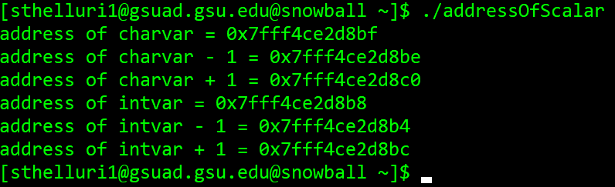

#include <stdio.h>

int main(){

char charvar = '\0';

printf("address of charvar = %p\n", (void \*)(&charvar));

printf("address of charvar - 1 = %p\n", (void \*)(&charvar - 1));

printf("address of charvar + 1 = %p\n", (void \*)(&charvar + 1));

int intvar = 1;

printf("address of intvar = %p\n", (void \*)(&intvar));

printf("address of intvar - 1 = %p\n", (void \*)(&intvar - 1));

printf("address of intvar + 1 = %p\n", (void \*)(&intvar + 1));

}

The intvar would be incremented by 4 bytes as opposed to 1 because an intvar takes 4 bytes of memory and a char takes 1 byte of memory.

3.

a.

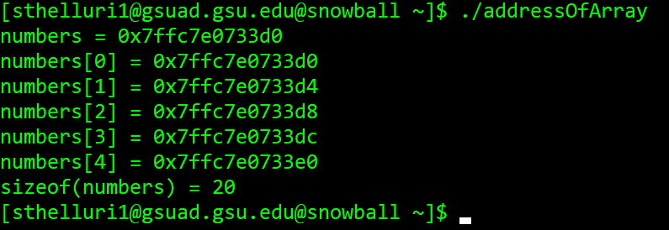

b. Yes, they are the same.

c. printf(“length of the (numbers) = %lu\n”, sizeof(numbers)/sizeof(numbers[0]);